Answer 1
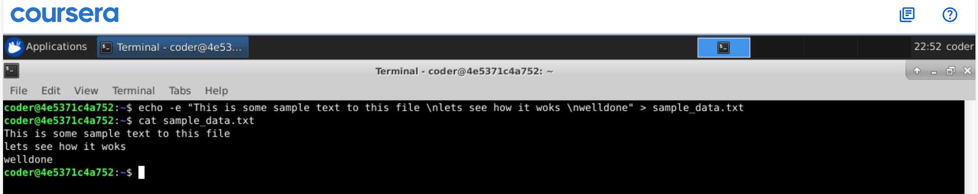
Explanation: By using echo command with -e option and > standard output to sample_data.txt we have achieved desired output in 1 line.

